**Aim -**

To study and implement Database as a Service on SQL/ NoSQL databases like AWS RDS, Azure SQL, MongoDB or Firebase.

**Theory -**

What is Database as a Service(DBaaS)?

Database as a Service (DBaaS) is a cloud-based service model that provides users with access to a managed database system, eliminating the need for users to set up, configure, and maintain their own database infrastructure. In a DBaaS model, the cloud service provider handles tasks such as provisioning, scaling, backup, security, and maintenance of the database, allowing users to focus on their applications and data management tasks.

Advantages of DBaaS:

* Reduced Management Overhead: DBaaS eliminates the need for users to manage the underlying infrastructure, including hardware provisioning, software installation, patching, and maintenance, which reduces administrative overhead and allows organizations to focus on their core business activities.
* Scalability: DBaaS platforms typically offer scalability features that allow users to easily scale their database resources up or down based on demand. This elasticity enables organizations to accommodate fluctuating workloads and scale their database resources cost-effectively.
* High Availability and Fault Tolerance: Many DBaaS providers offer built-in high availability and fault tolerance features, such as automated failover, data replication, and backups, to ensure continuous availability and data protection.
* Cost Efficiency: DBaaS often follows a pay-as-you-go pricing model, where users only pay for the resources they consume. This can result in cost savings compared to traditional on-premises database deployments, as users are not required to invest in upfront hardware and infrastructure costs.
* Faster Time to Market: DBaaS platforms streamline the database provisioning process, allowing users to quickly deploy and configure databases without the need for lengthy setup and configuration tasks. This accelerates the development and deployment of applications, reducing time to market.

Disadvantages of DBaaS:

* Limited Control: With DBaaS, users relinquish some level of control over the database infrastructure to the service provider. This lack of control may be a concern for organizations with specific security, compliance, or customization requirements.
* Data Security and Privacy Risks: Storing sensitive data in a third-party cloud environment raises concerns about data security and privacy. Organizations must carefully evaluate the security measures implemented by DBaaS providers to ensure compliance with regulatory requirements and protect their data from unauthorized access and breaches.
* Vendor Lock-In: Migrating data between different DBaaS providers or transitioning from DBaaS to an on-premises deployment may be challenging and costly, leading to vendor lock-in. Organizations should consider the long-term implications of vendor lock-in and evaluate strategies to mitigate this risk.
* Performance and Latency: Performance and latency issues may arise in DBaaS environments, particularly in multi-tenant deployments where resources are shared among multiple users. Organizations should assess the performance characteristics of DBaaS offerings and ensure they meet their performance requirements before migration.
* Dependency on Internet Connectivity: DBaaS relies on internet connectivity for accessing and managing database resources, which may pose challenges in environments with limited or unreliable internet connectivity. Organizations should consider the potential impact of internet outages or disruptions on their database operations and implement contingency plans accordingly.

**Procedure -**

Step1 : Login to aws console and search RDS.

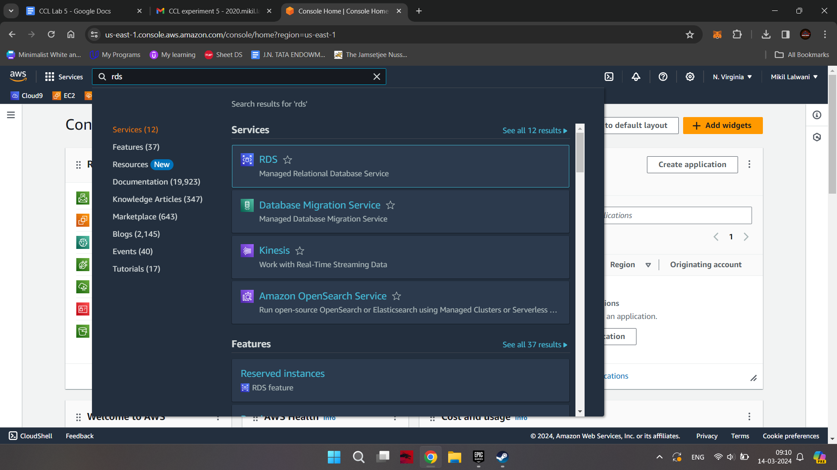

Step2: Click on to RDS and create database

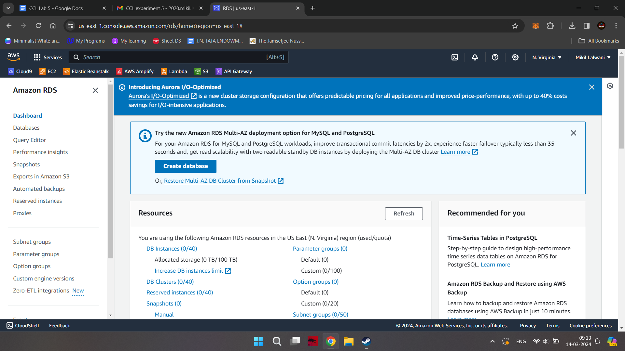

Step 3: Select standard database

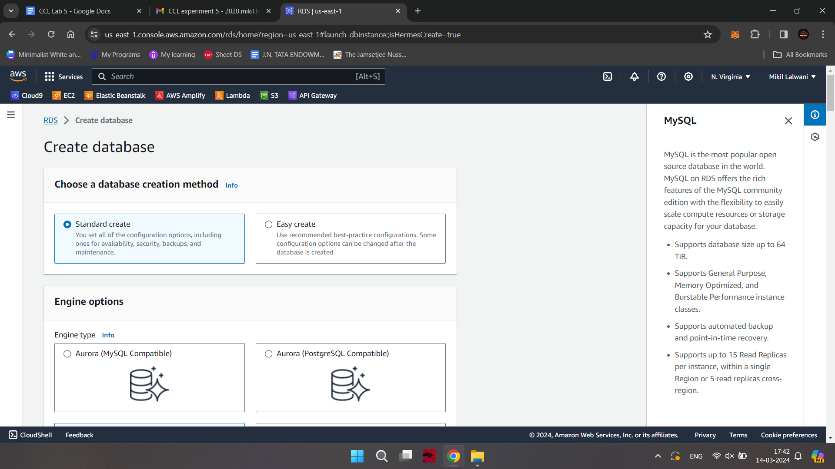

Step 4: Select MySQL and MySQL Community edition

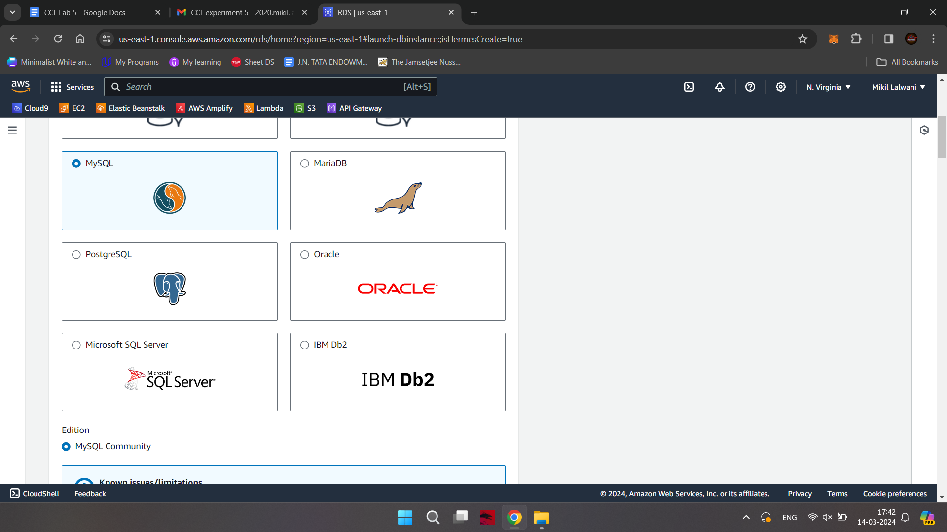

Step 5:In Templates select Free tier.

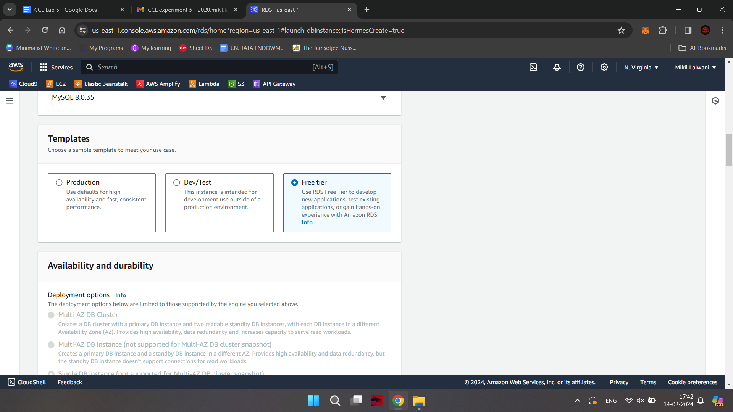

Step 6: Mention database name (default is database1) and username and password

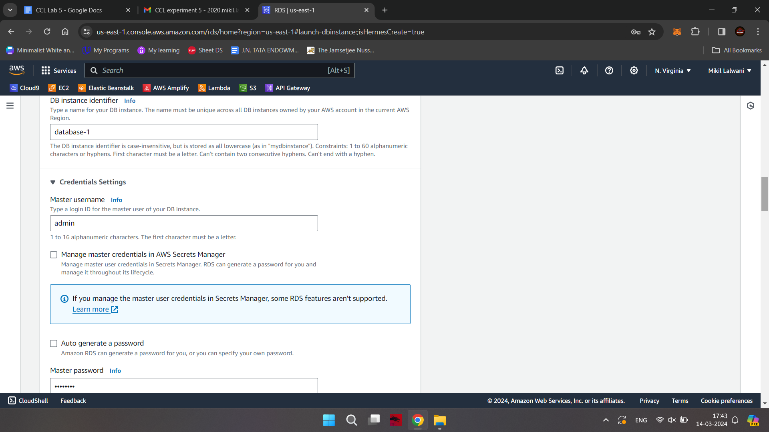

Step 7: Instance is t2.micro

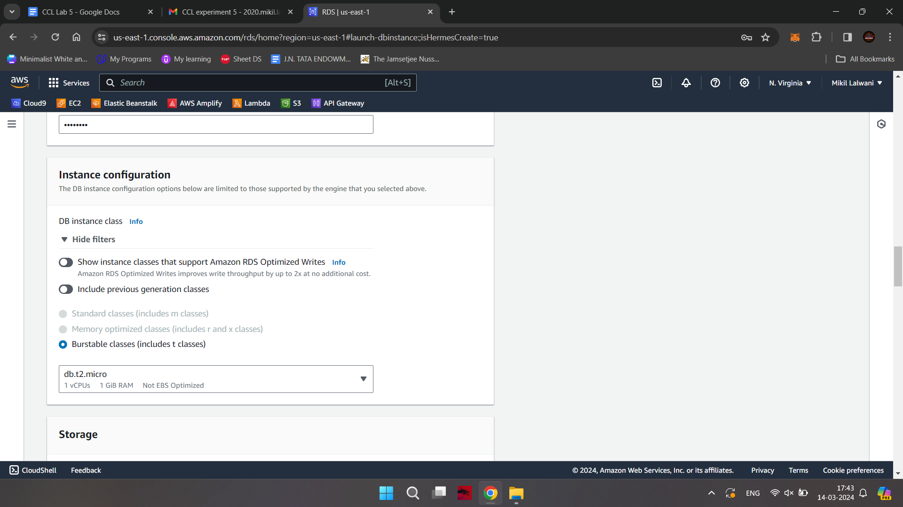

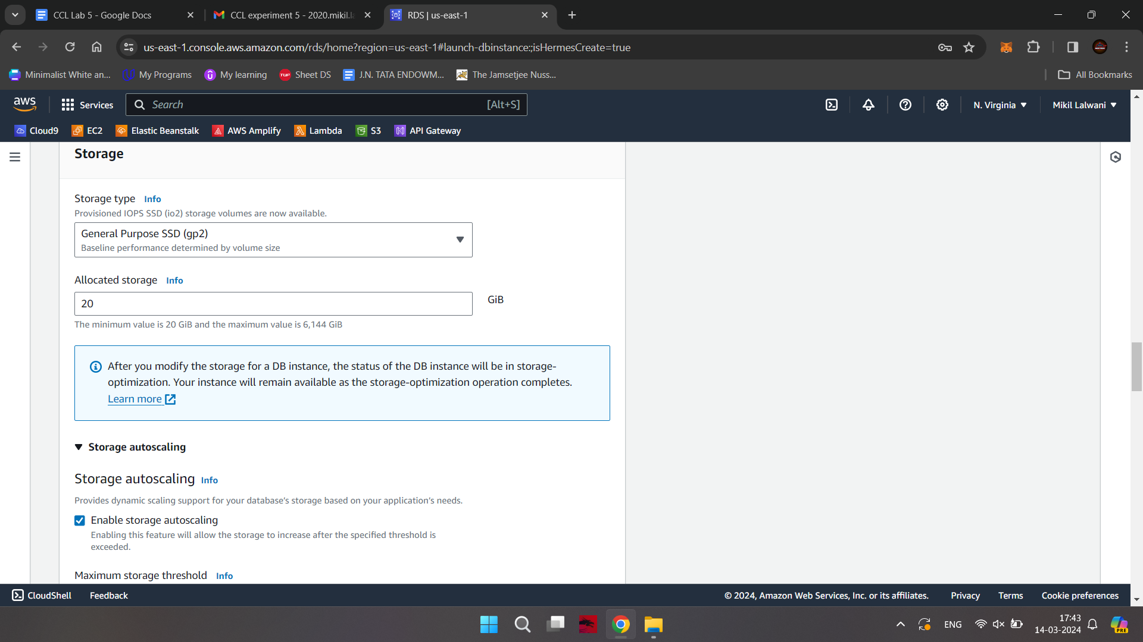

Step 8: Select Public Access -Yes

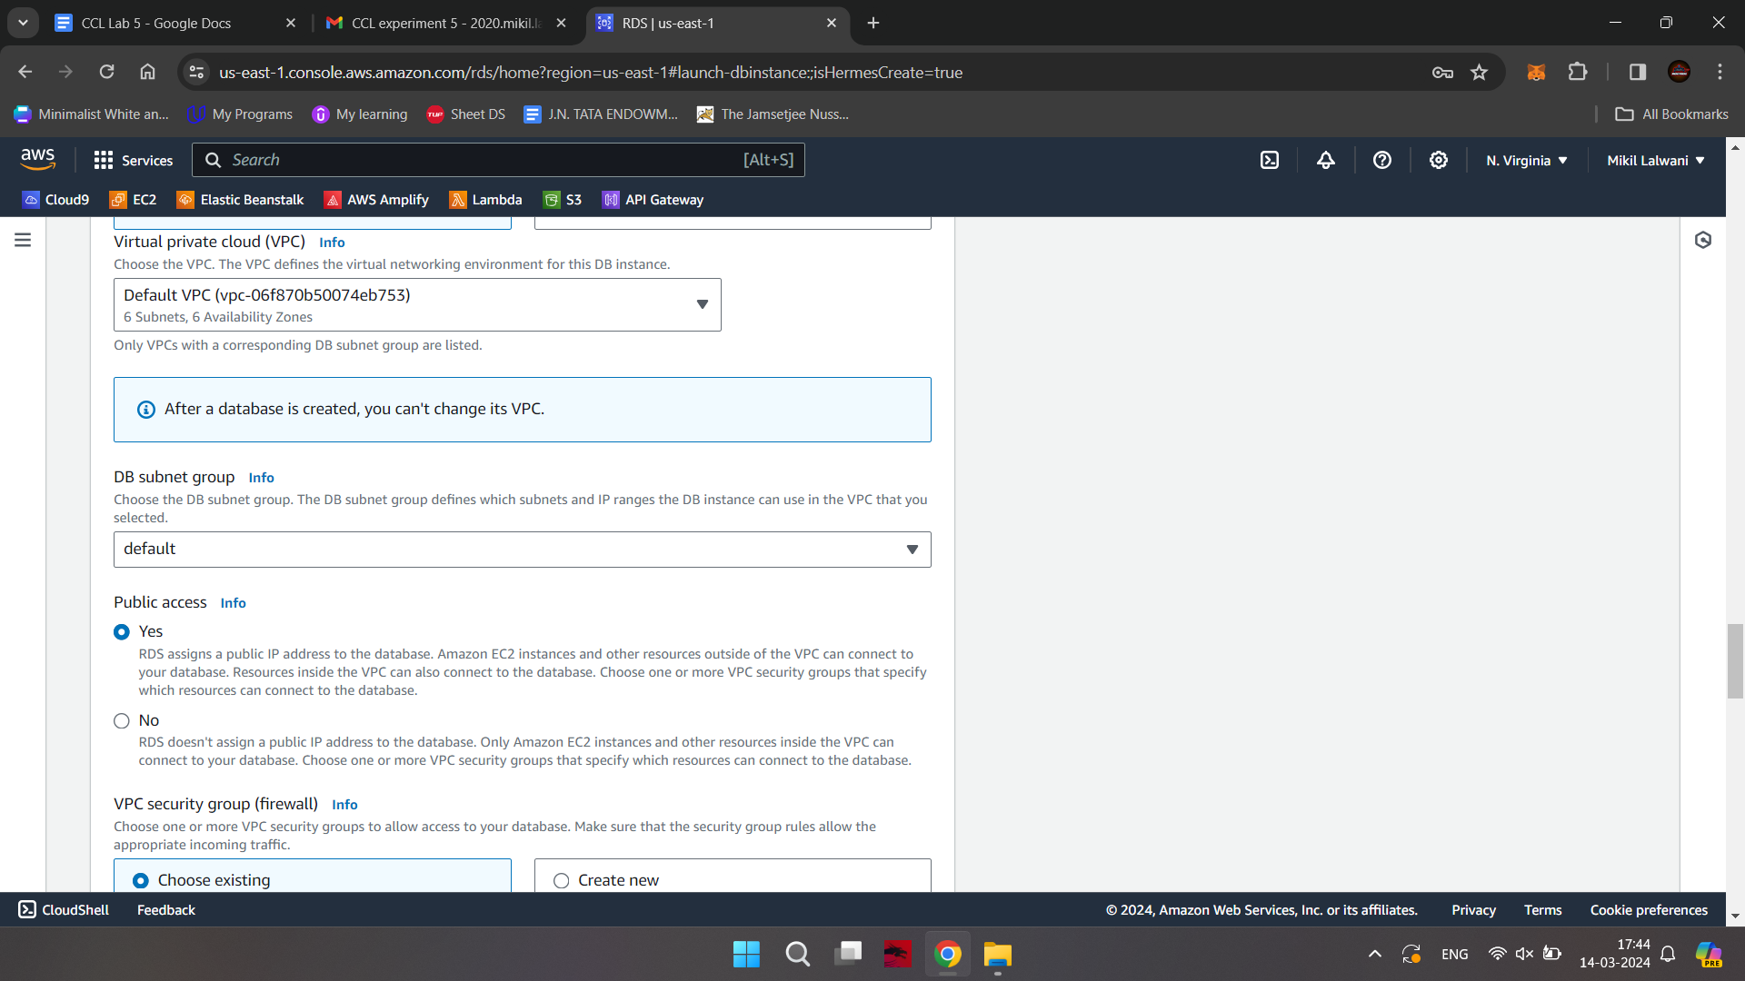

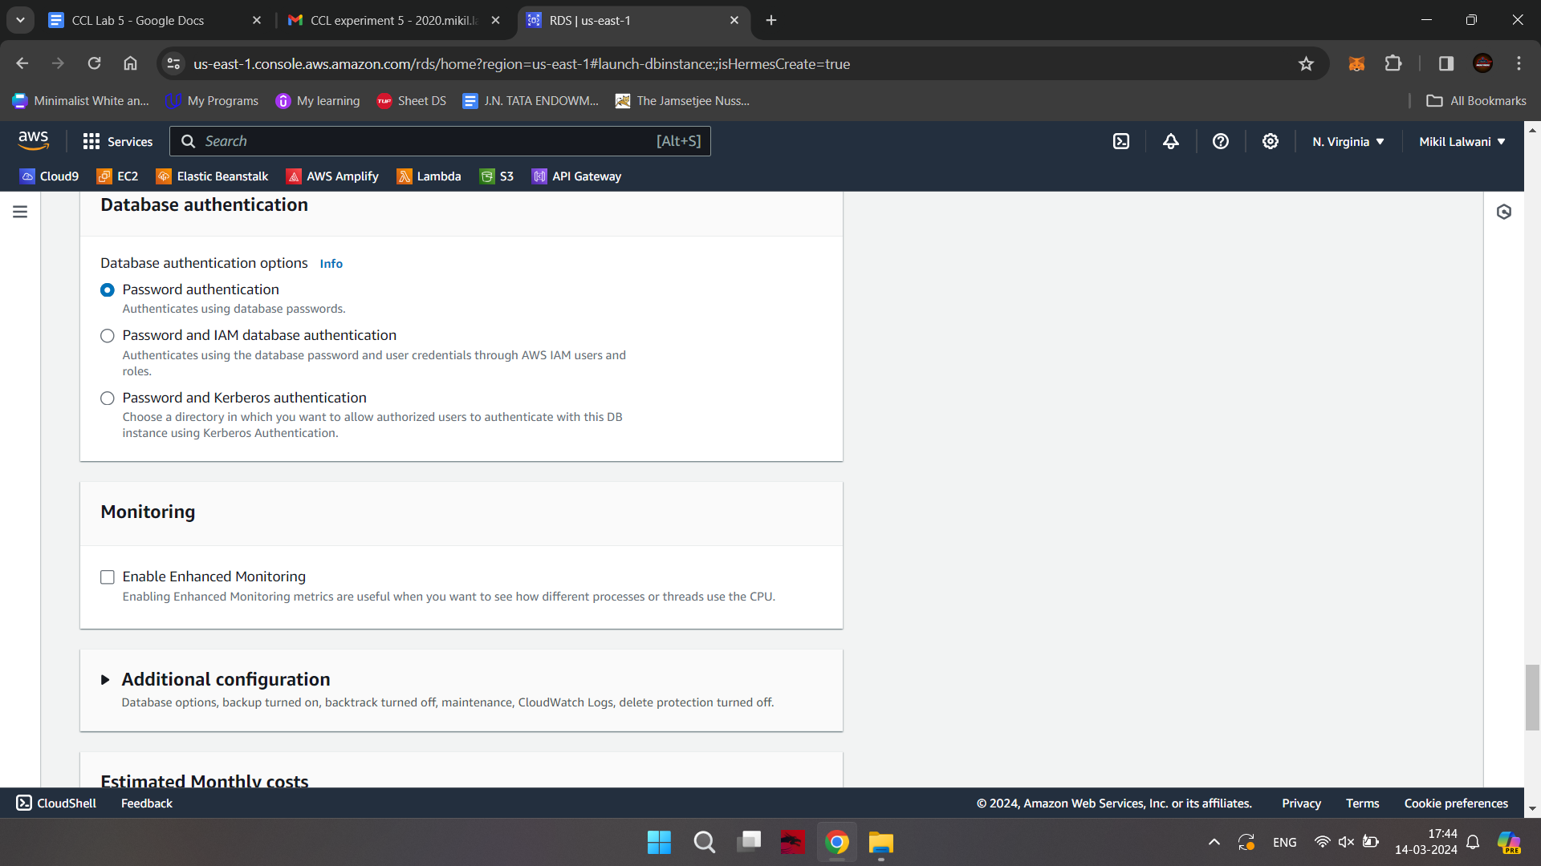

Step 9: Click on to create Database

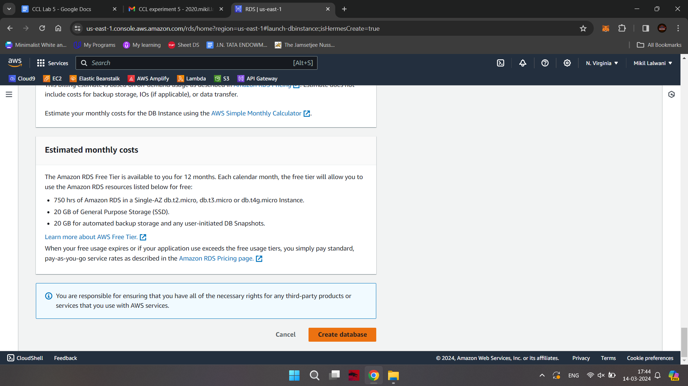

Step 10: It will take some time

Step 11: Go to google type mysql workbench

Step 12: Click on to download. MySQL community download – Microsoft Windows

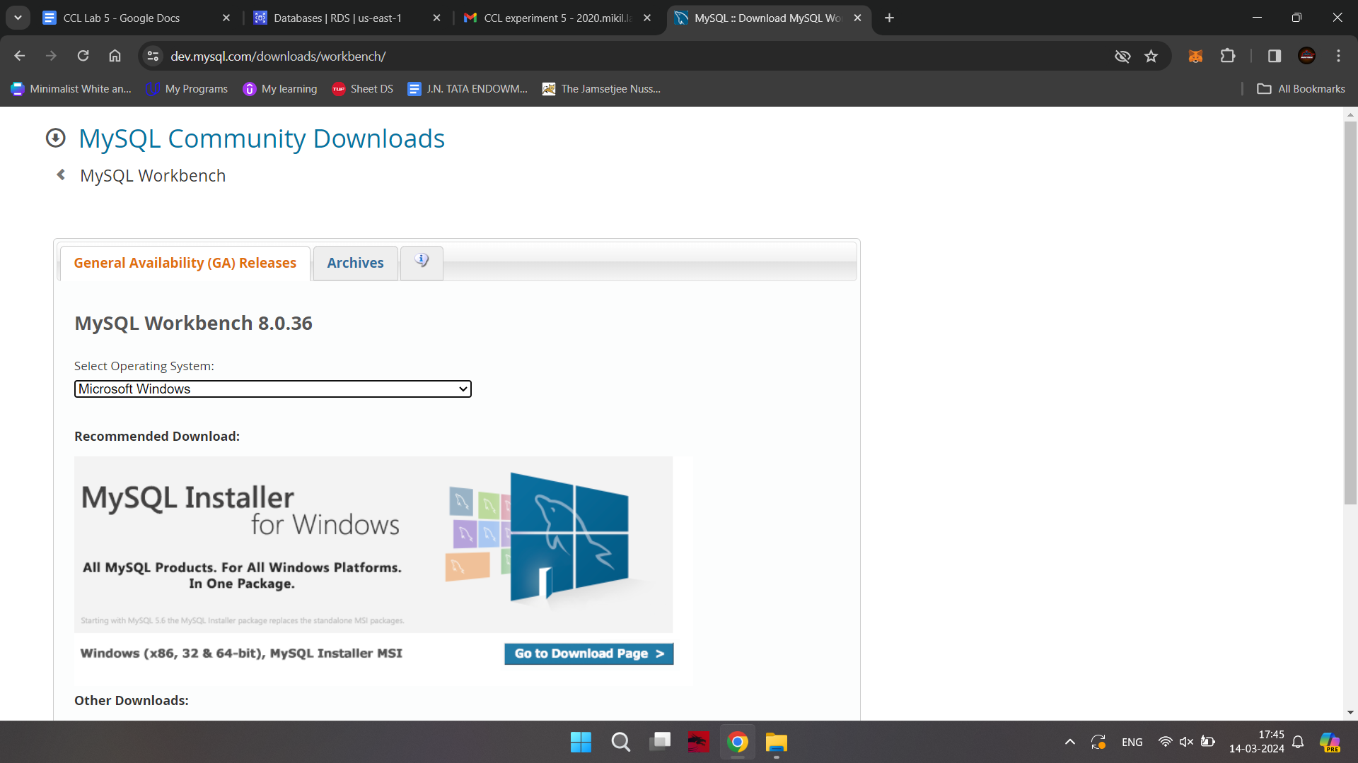

Step 13: Click on to – No thanks , just download

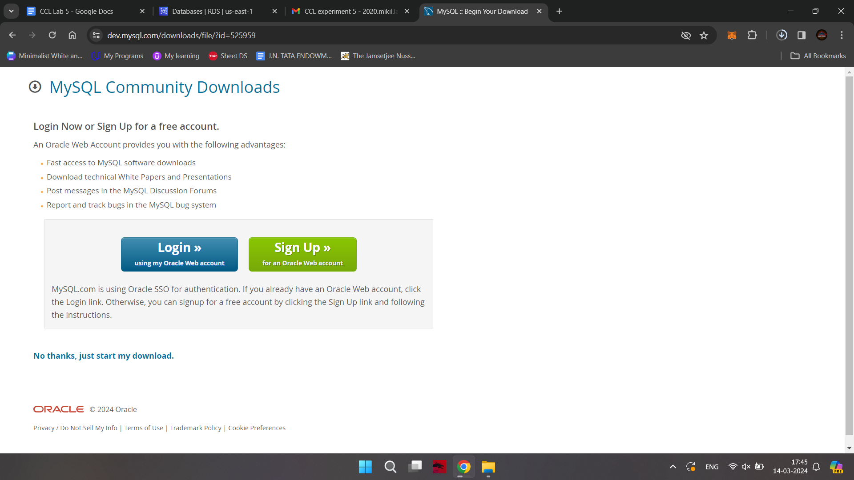

Step 14: Go to downloads of your machine and install it with default settings

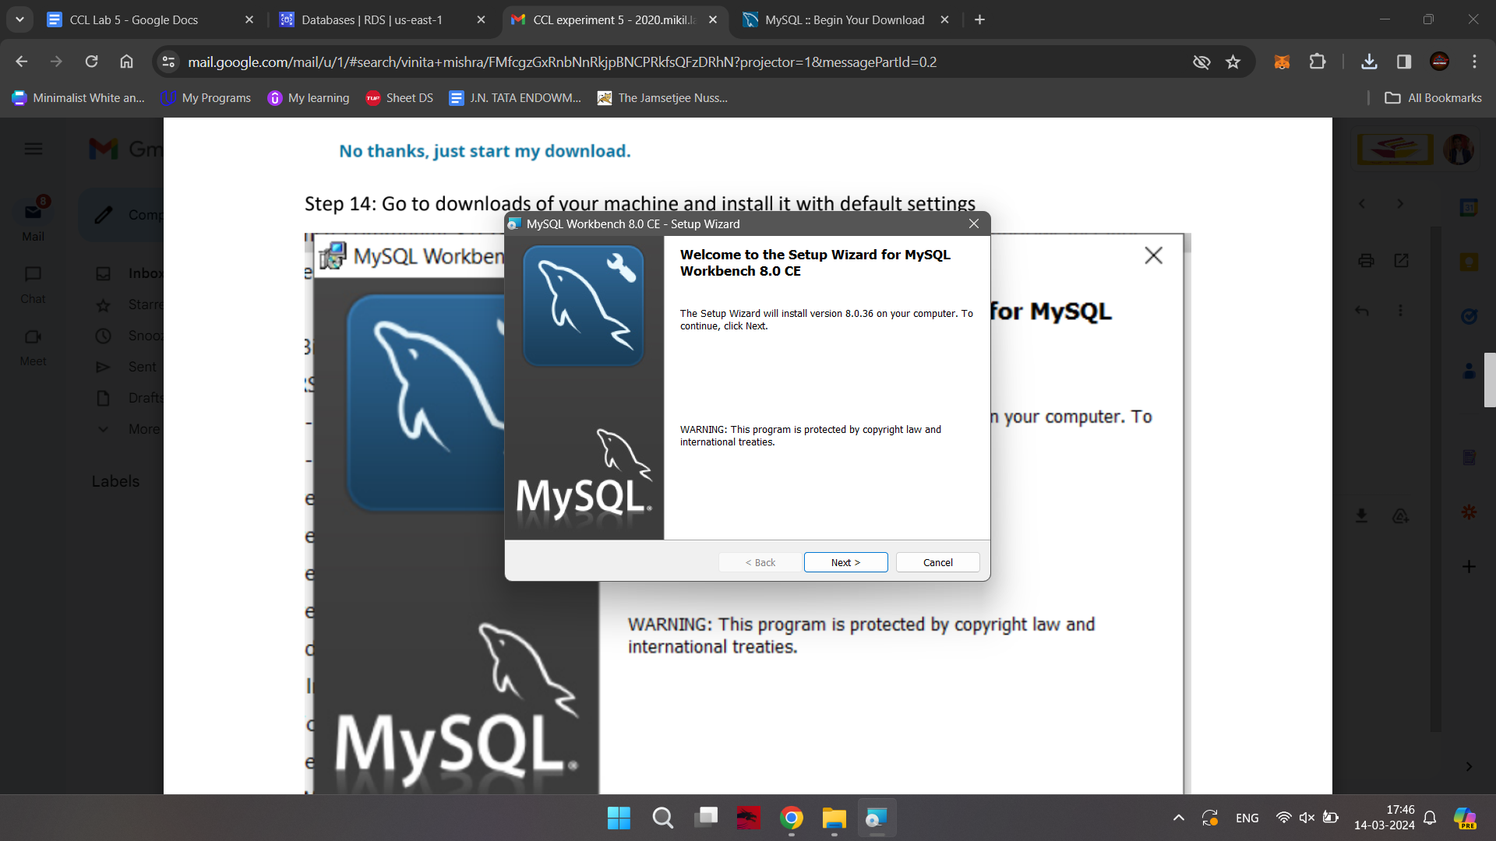

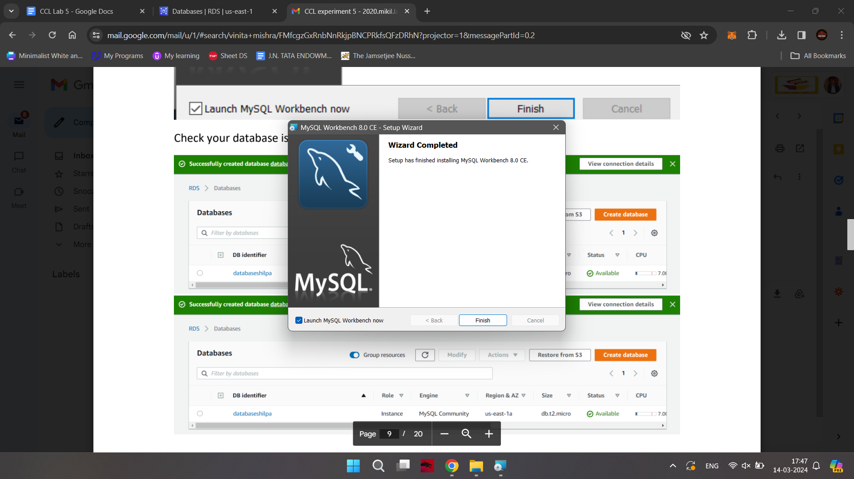

Check your database is created and status is available

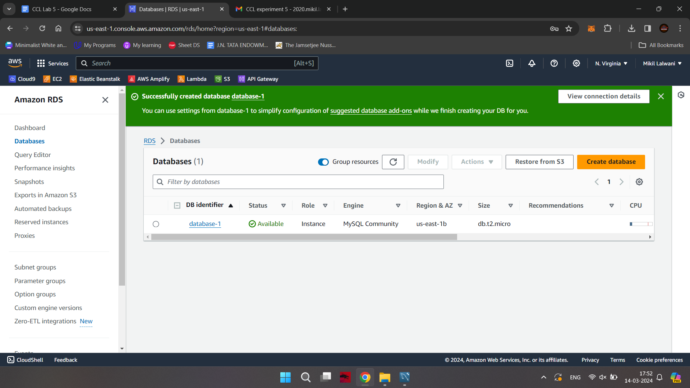

Step 16: Click on to database

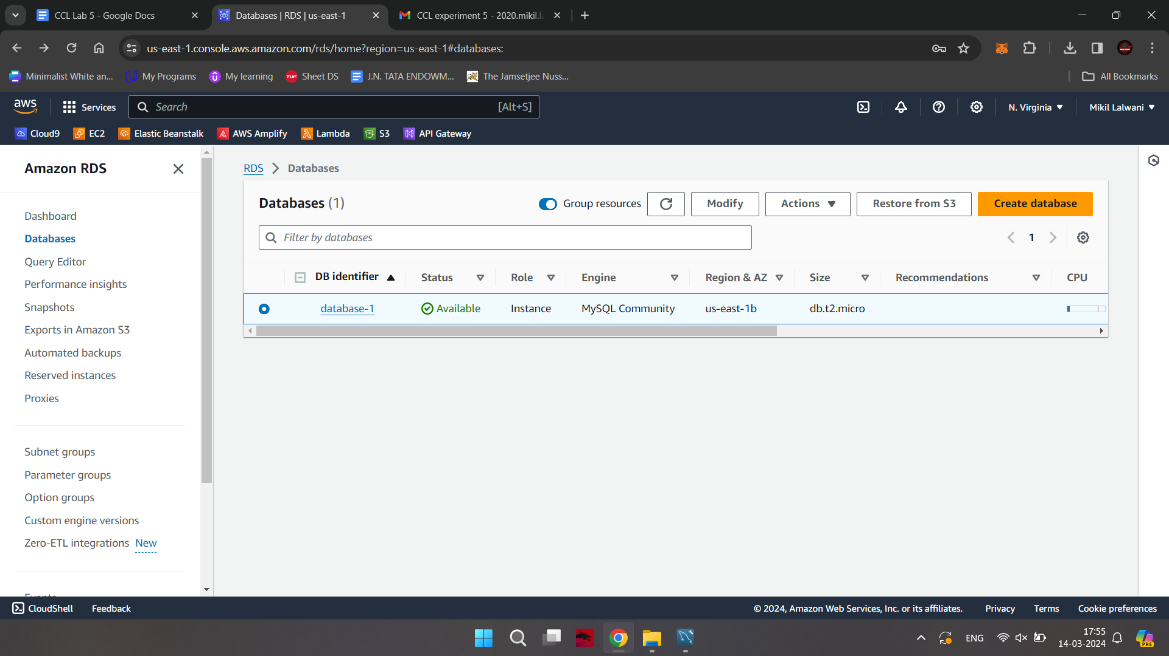

Step 17: Copy Endpoint

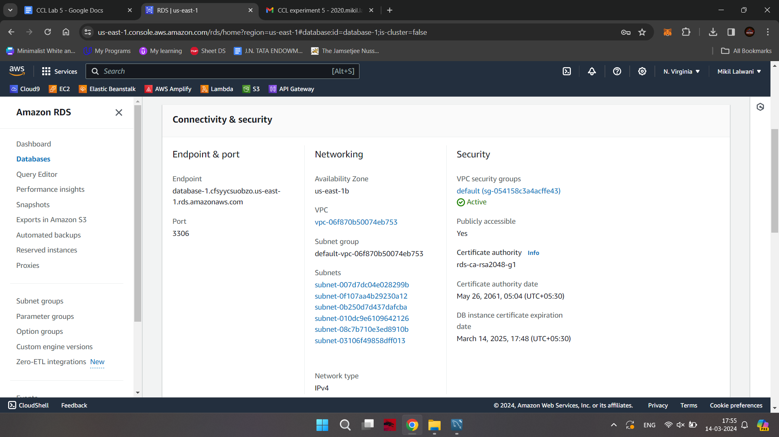

Step 18: Go back to workbench

Step 19: Click on to mysql connection

Step 20: Paste copied endpoint in Hostname

Connection Name : database-1

Username : admin

Click on to Test Connection

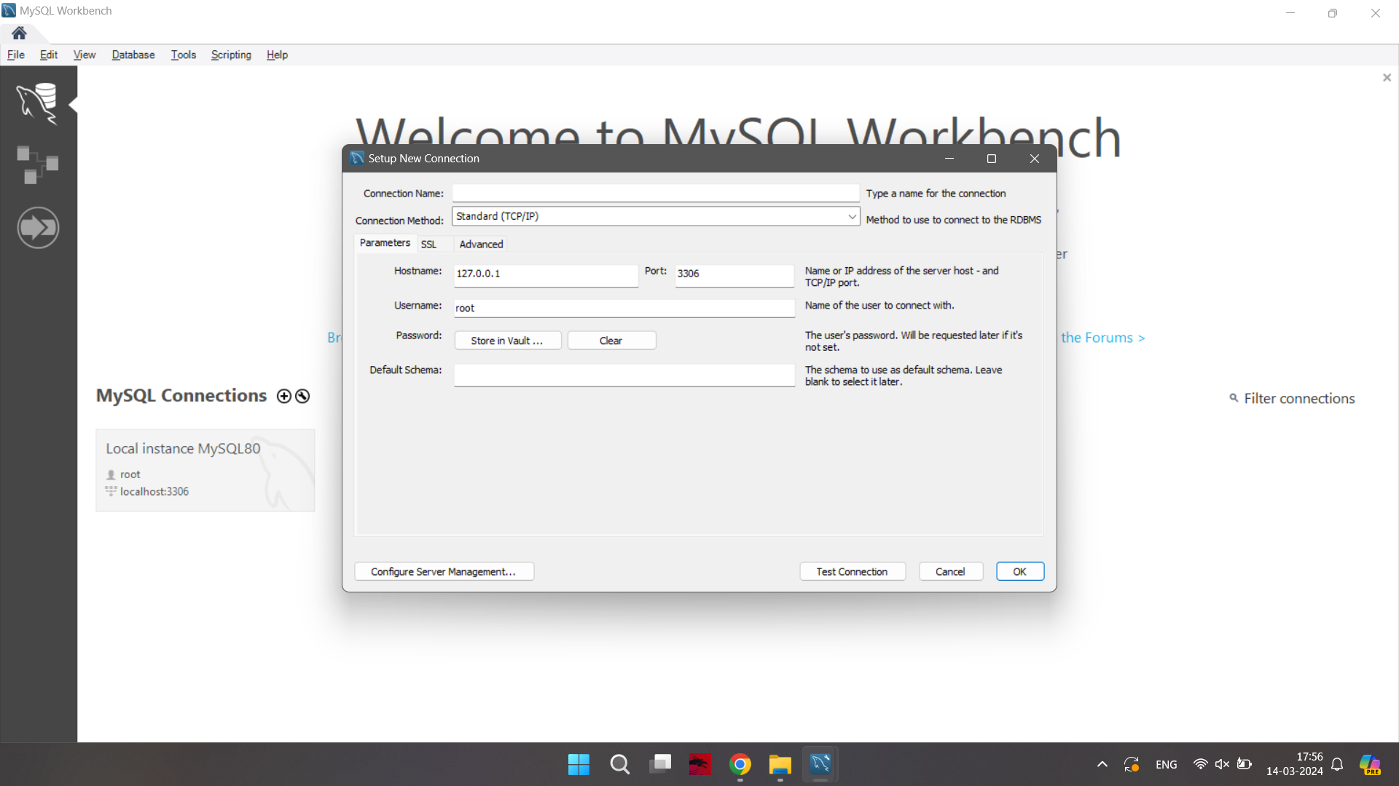

Step 21: Go to vpc security group

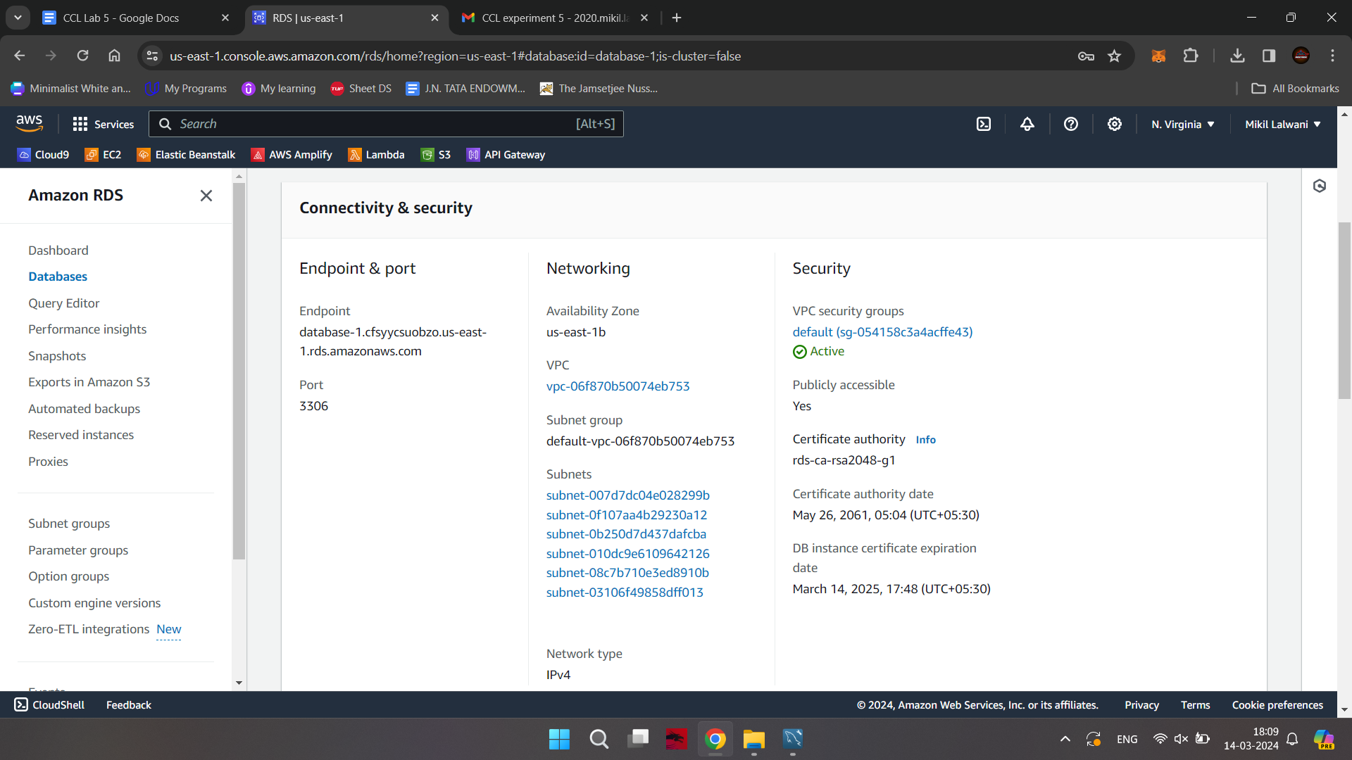

Step 22: Click on to inbound rules

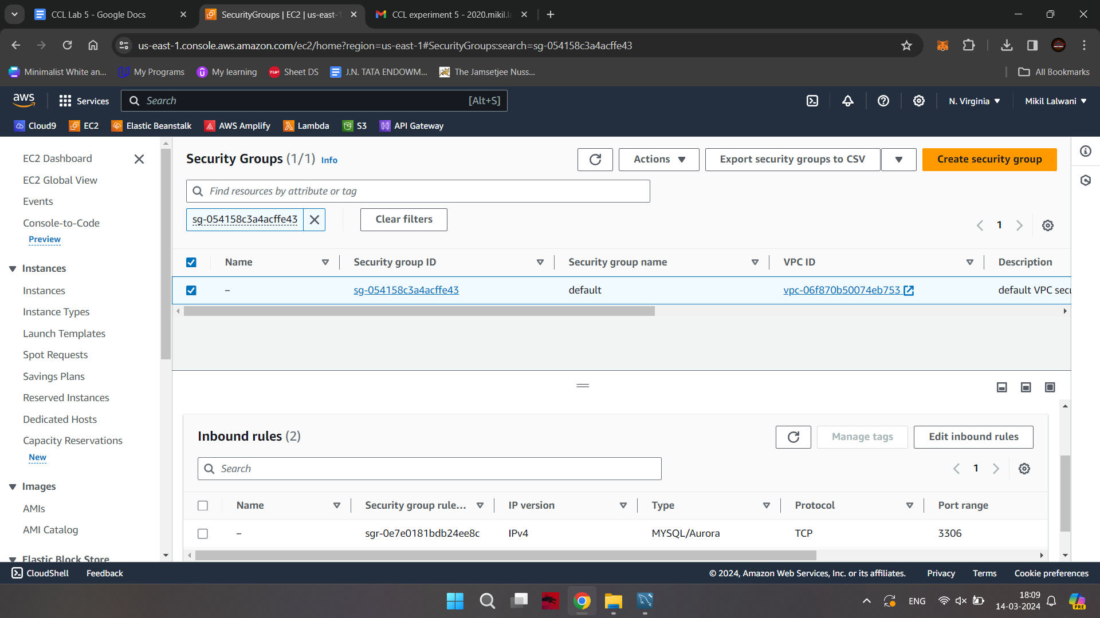

Step 23: First select Click on to Edit inbound rule add rule select ipv4 --all traffic (add 0.0.0.0./0) and save Rules

(important step to add inbound rule)

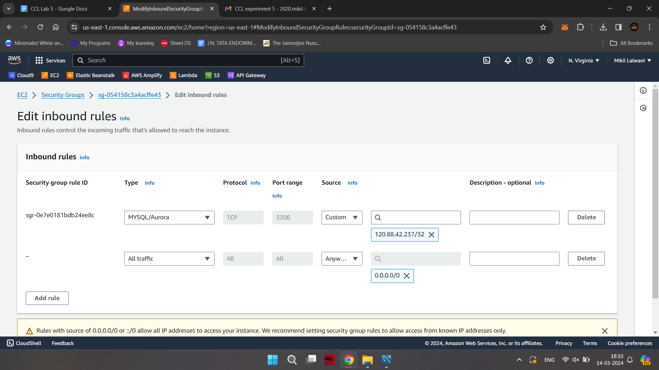

Step 24: Goto workbench (after giving details click on to Test Connection)

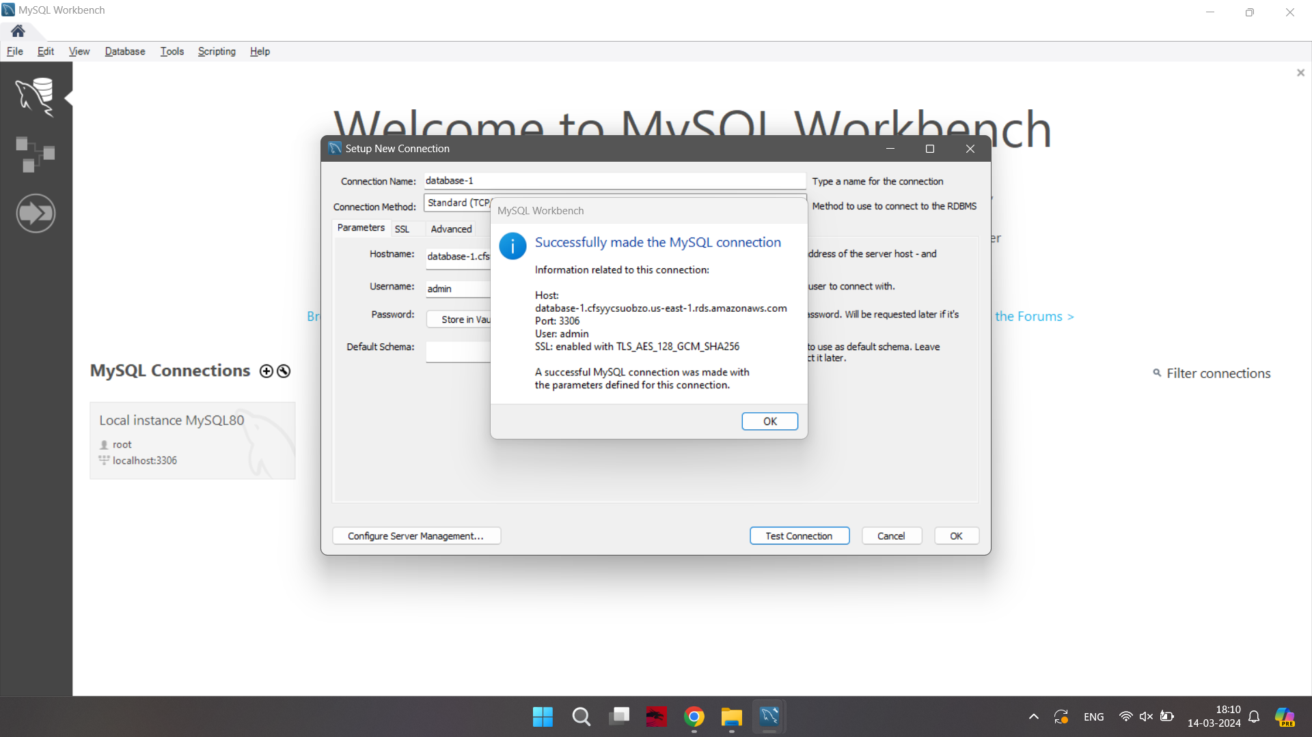

Click on Ok button

Go to workbench double click on connection(database-1)

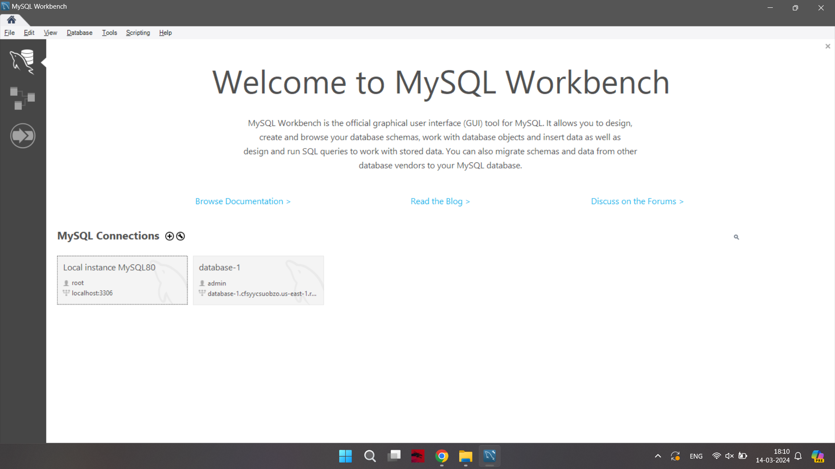

Step 25: Write query and execute

Create a database, and perform CRUD operations.

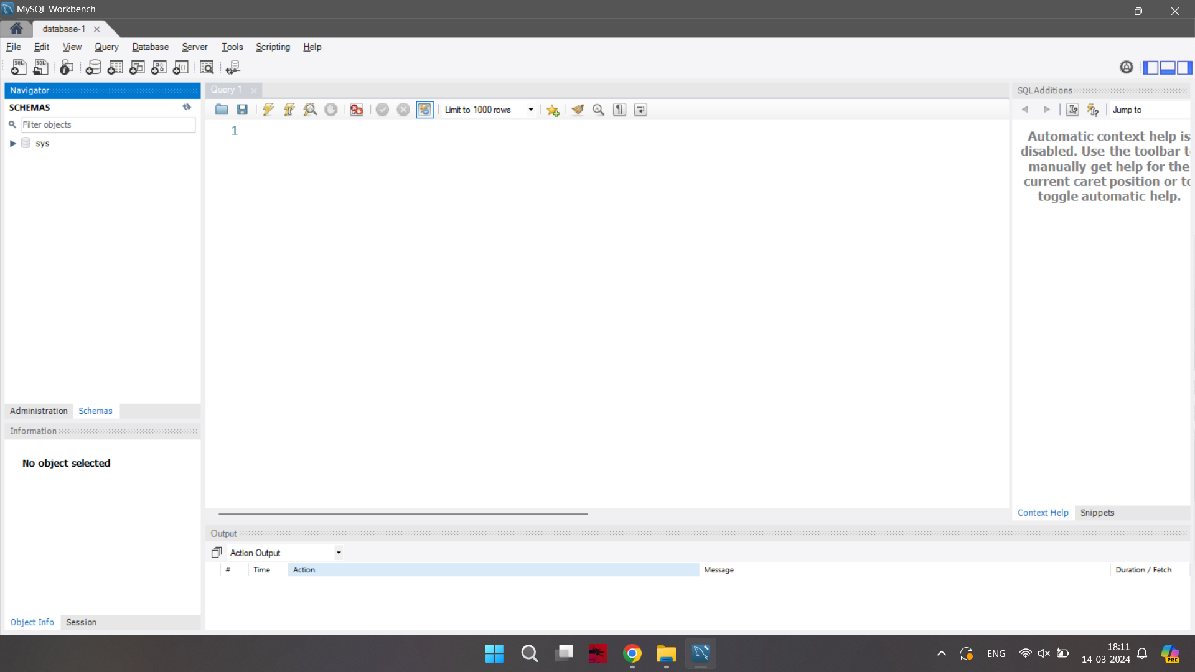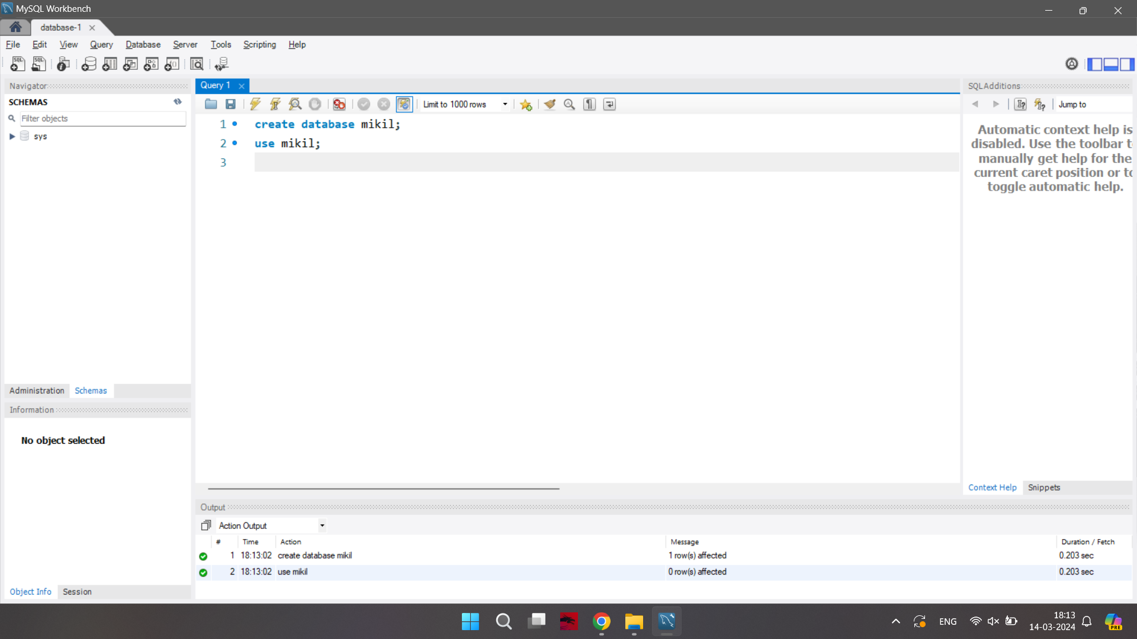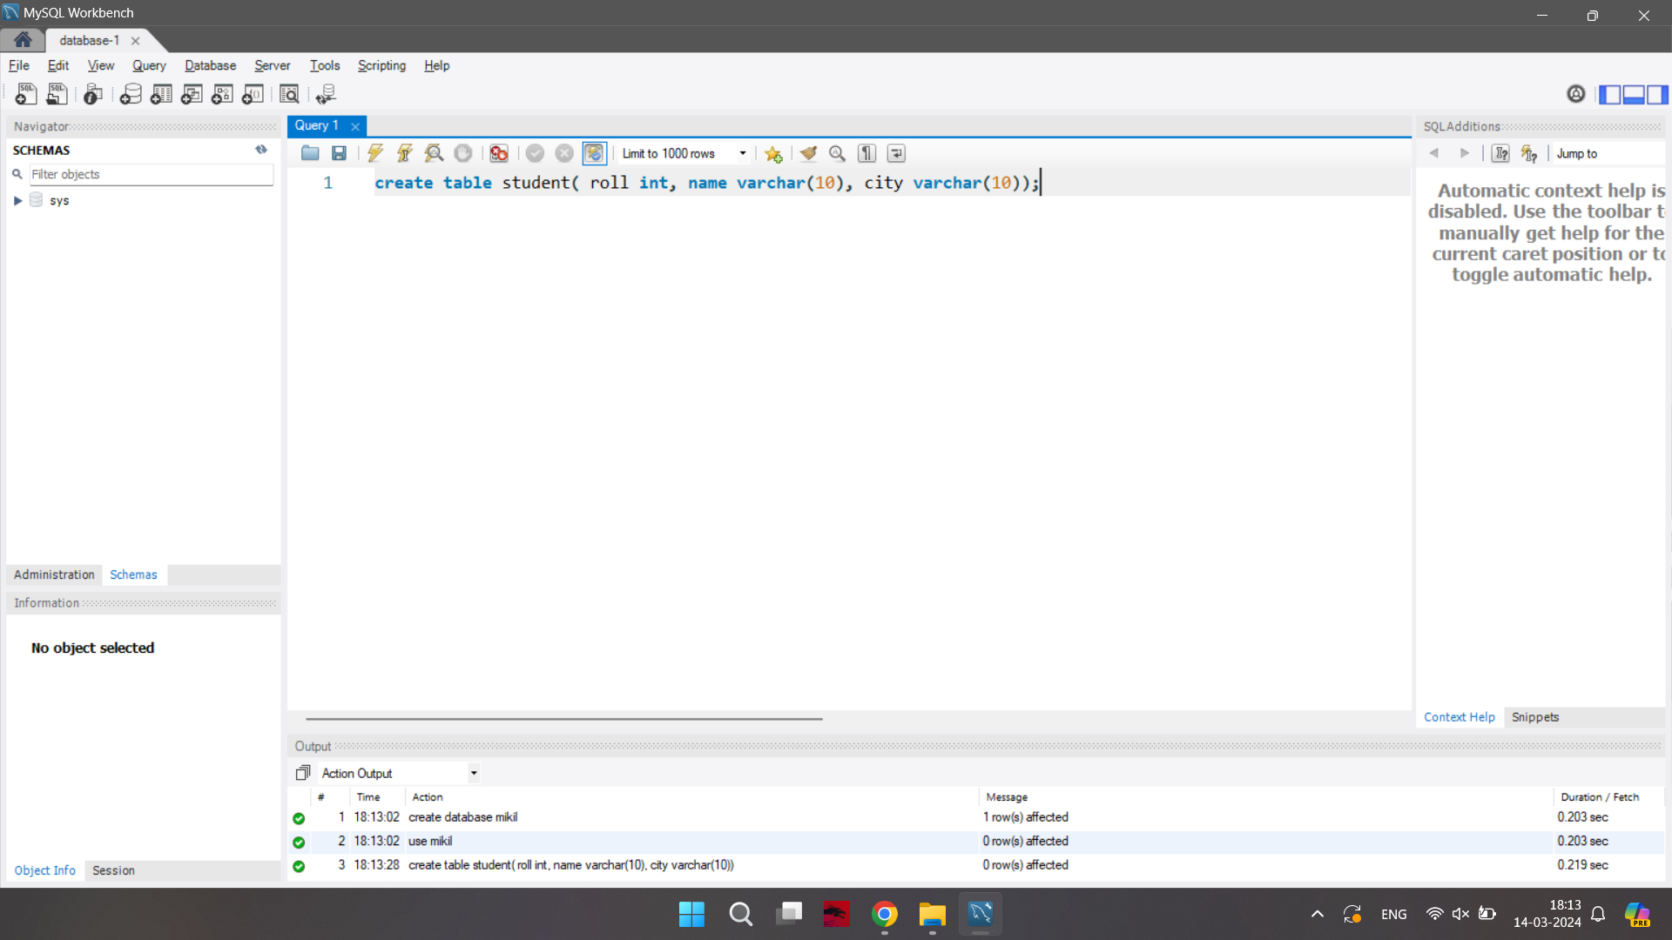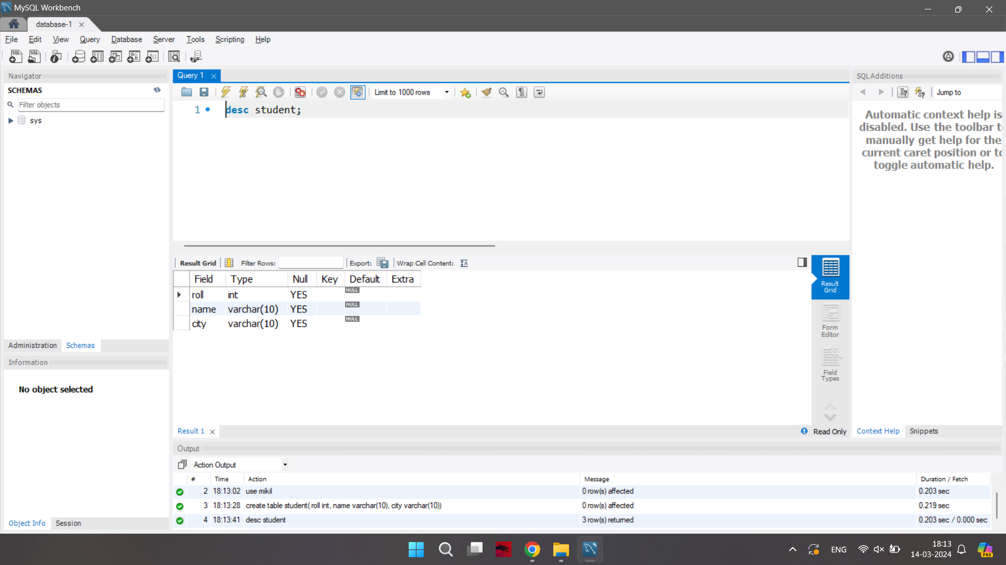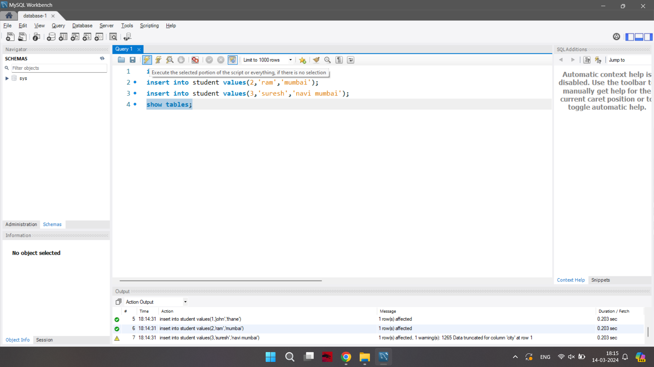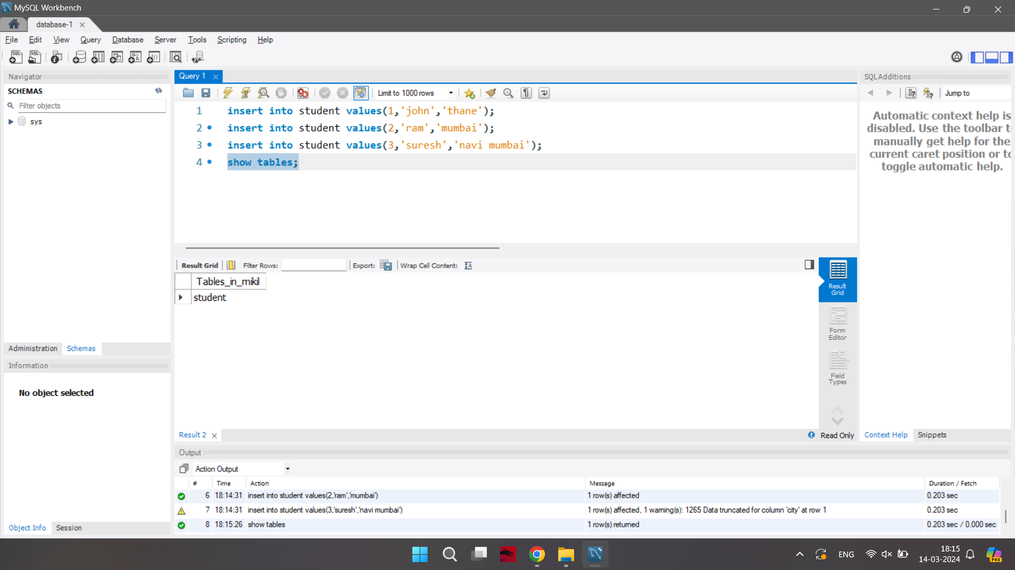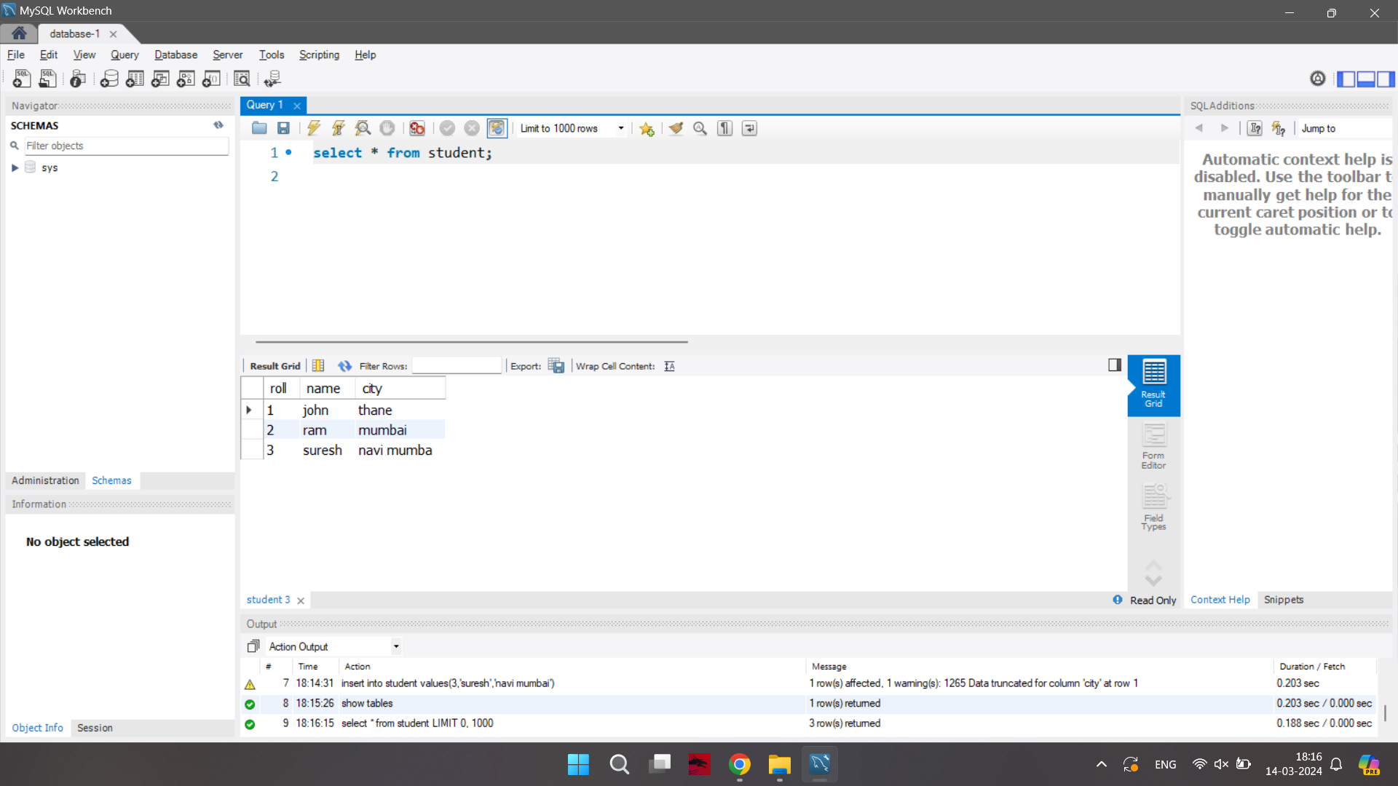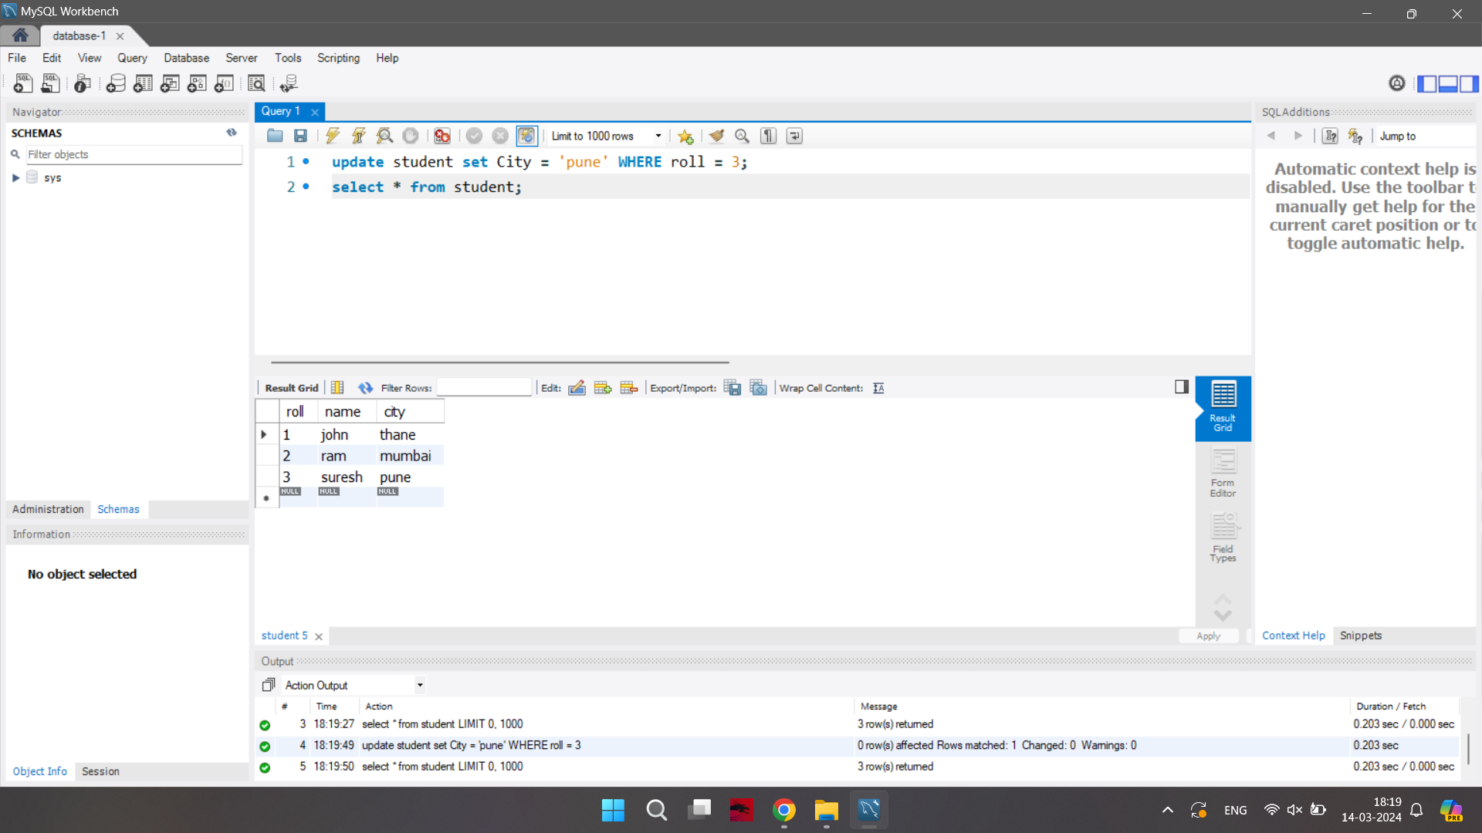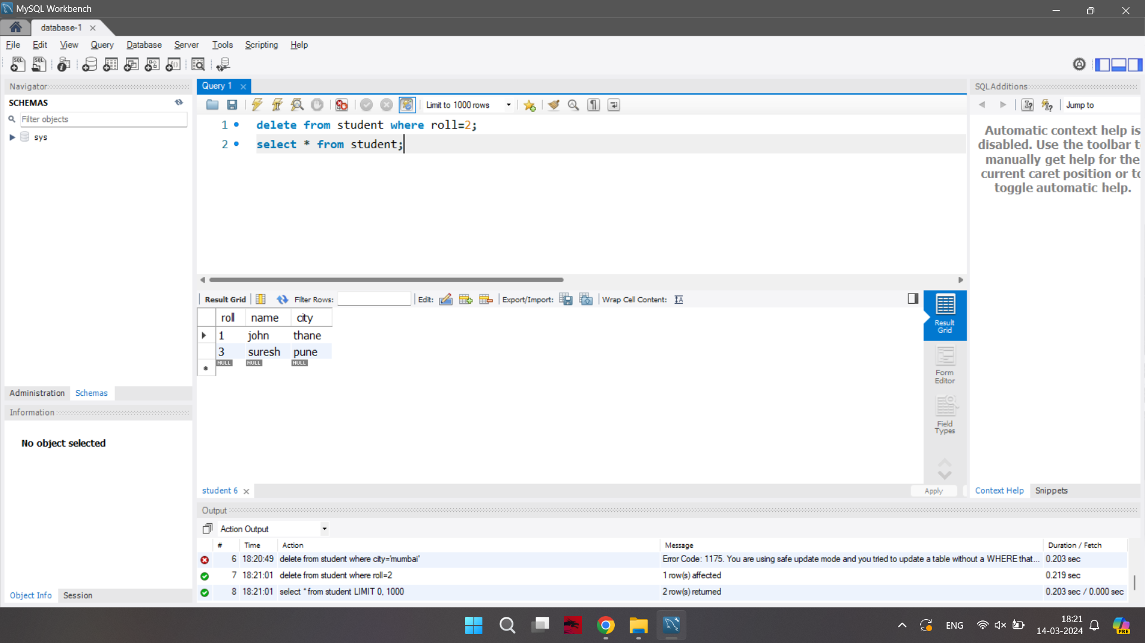

Step 26: Now delete the instance (once you have done with it)

Select instance go to action stop instance and then delete instance

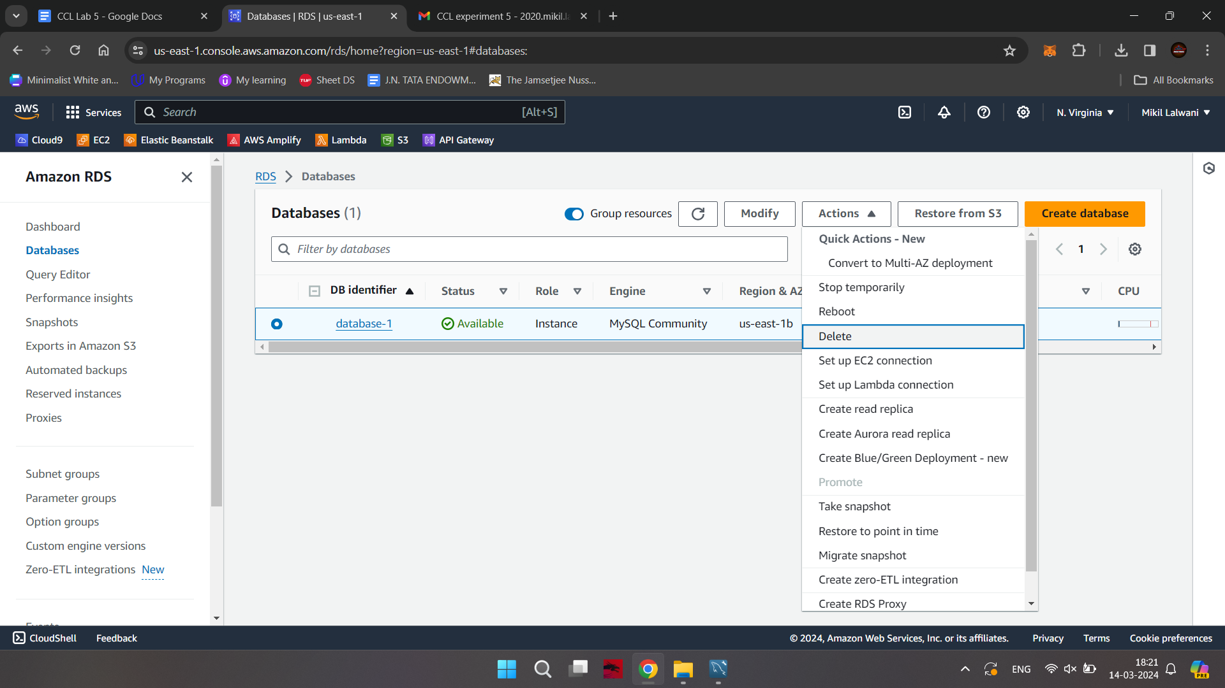

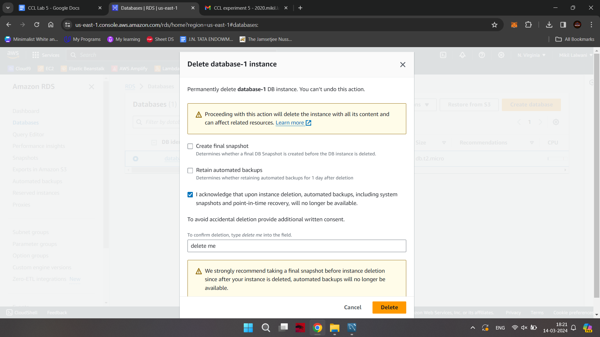

**Conclusion -**

Thus we have successfully learned about DBaaS and implemented it on AWS.